### Solving analytical queries on Redshift Cluster

1. **Top 10 ATMs where most transactions are in the ’inactive’ state**

SELECT atm_number, atm_manufacturer, location, total_transaction_count, inactive_count

FROM

(SELECT c.atm_number, c.atm_manufacturer, b.location,

COUNT(a.trans_id) as total_transaction_count,

SUM(CASE WHEN a.atm_status = 'Inactive' THEN 1 ELSE 0 END) inactive_count,

DENSE_RANK() OVER(ORDER BY inactive_count desc) rank

FROM upgrad_etl_proj.fact_atm_trans a,

upgrad_etl_proj.dim_location b, upgrad_etl_proj.dim_atm c

WHERE a.weather_loc_id = b.location_id

AND a.atm_id = c.atm_id

AND b.location_id = c.atm_location_id

GROUP BY c.atm_number, c.atm_manufacturer, b.location)

WHERE rank <= 10;

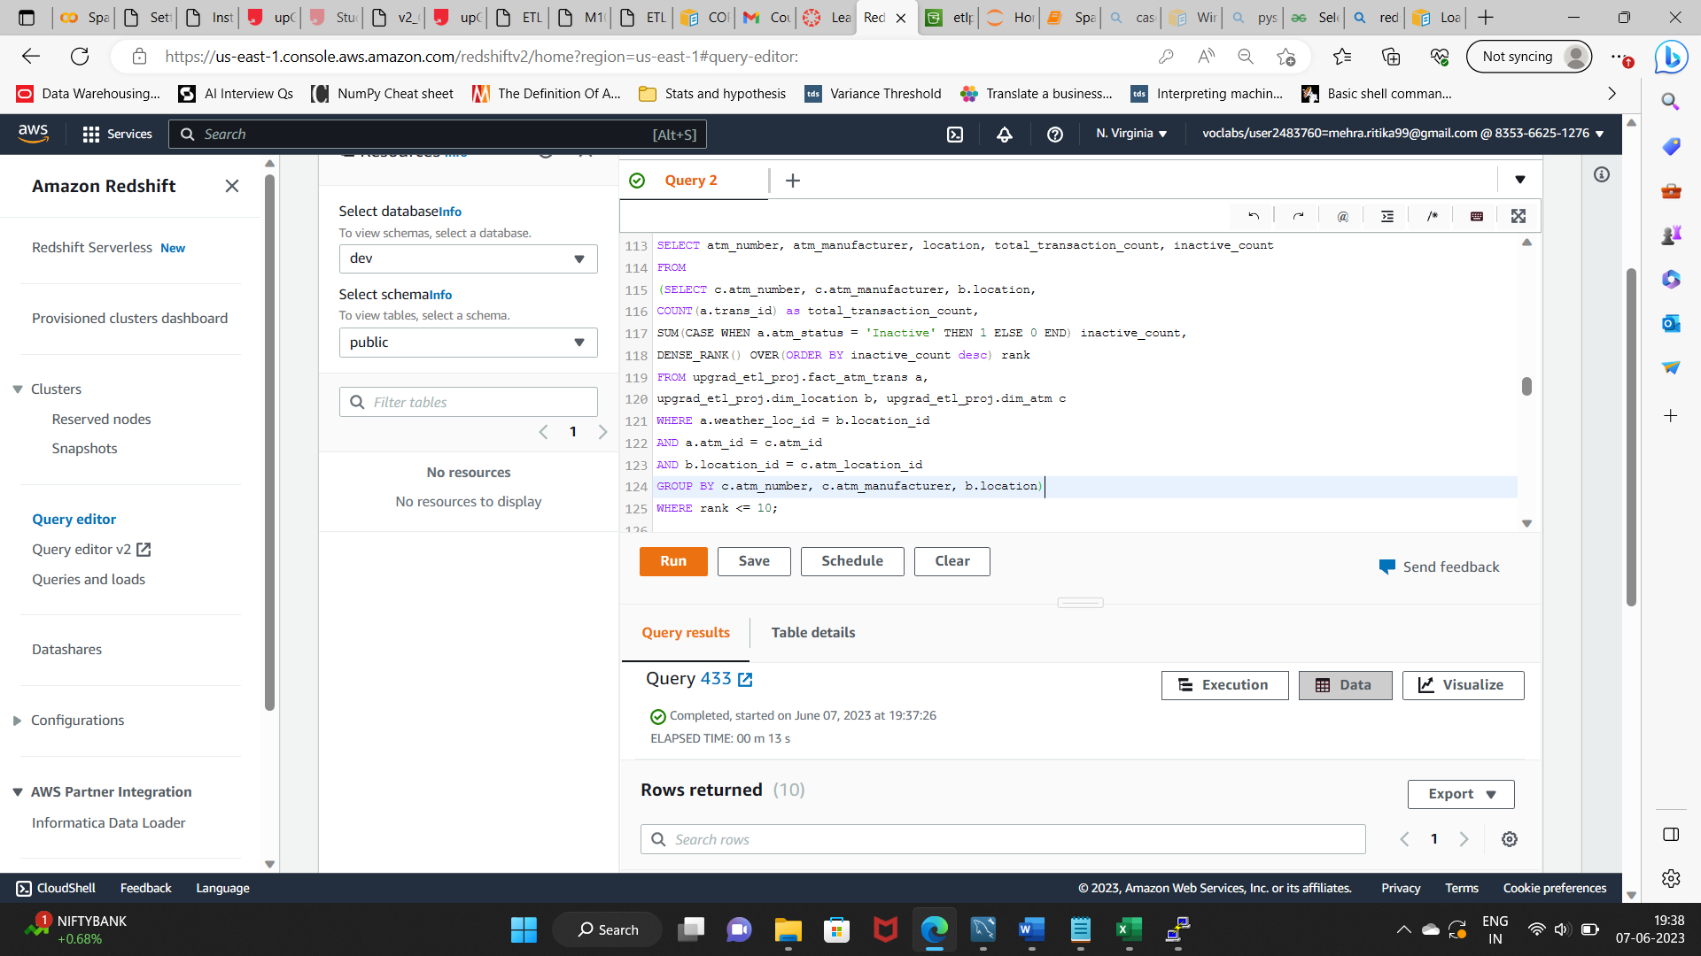

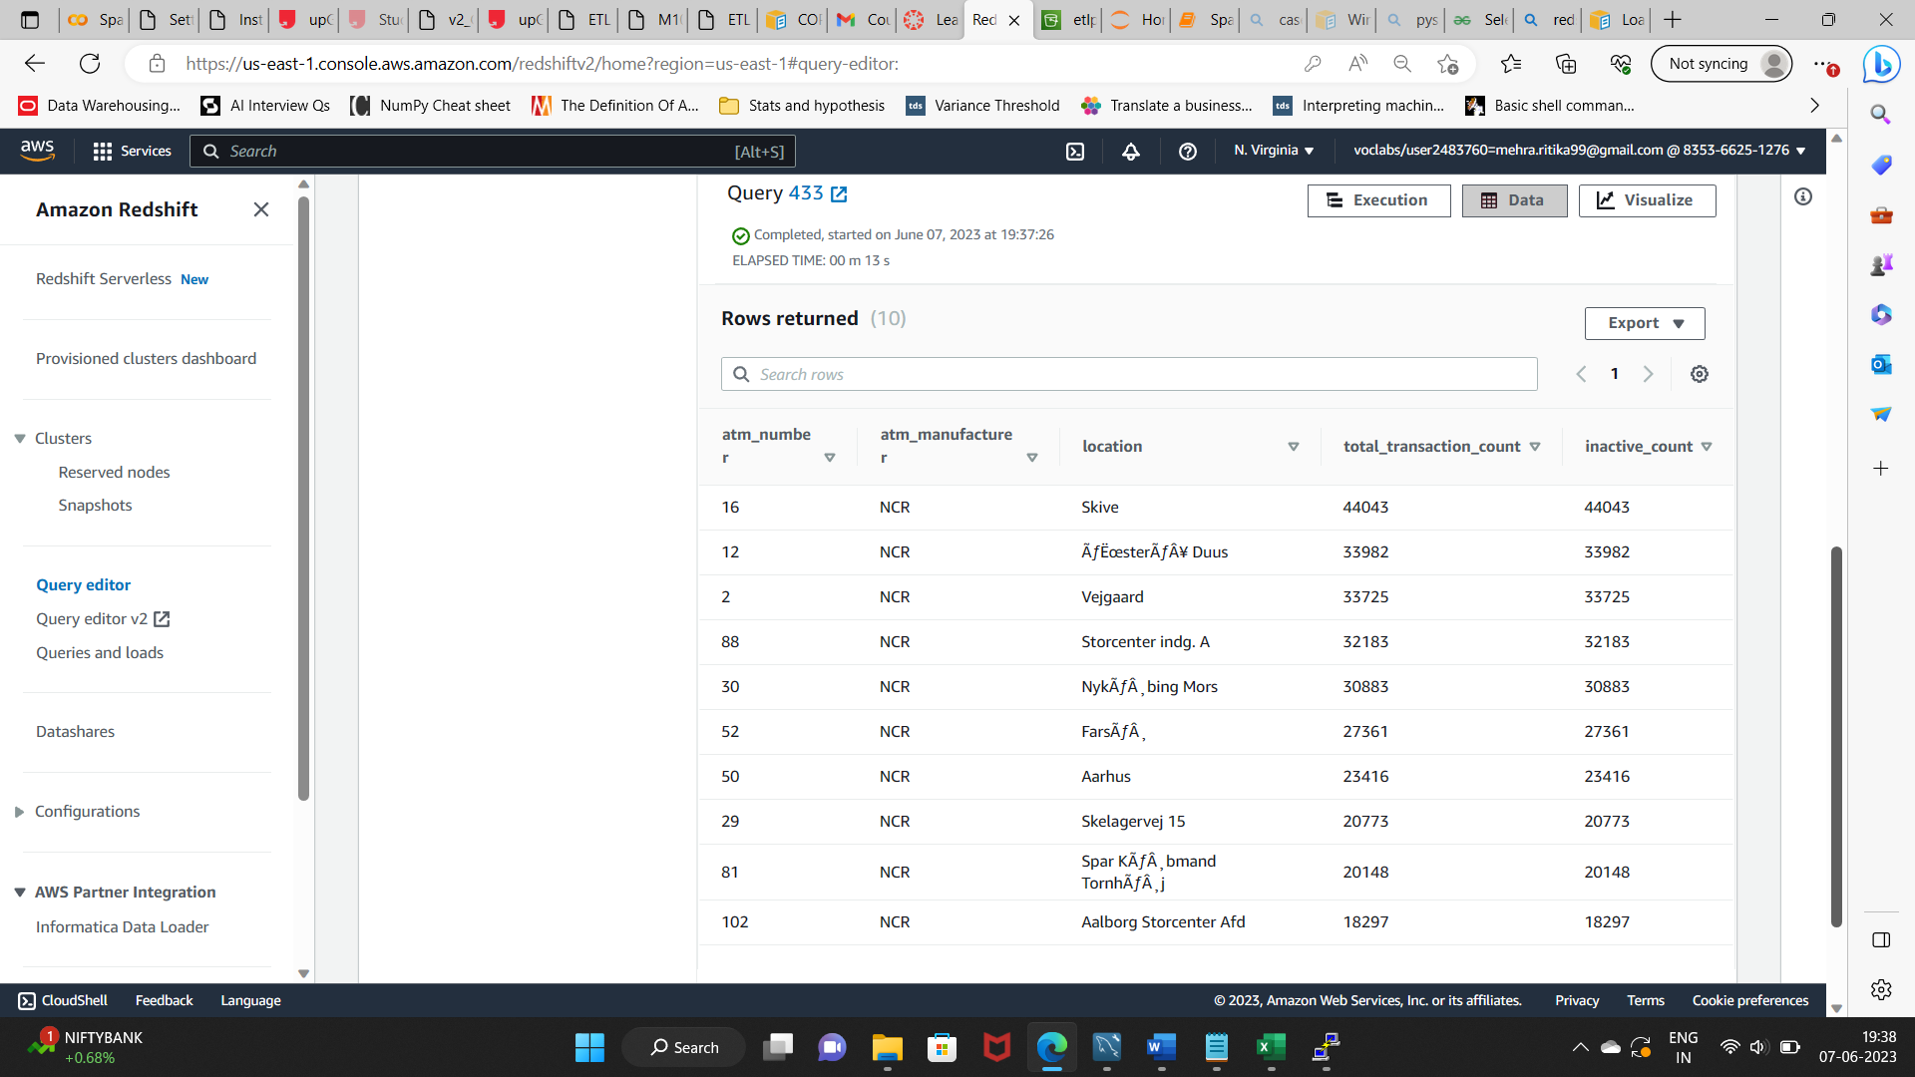

1. **Number of ATM failures corresponding to the different weather conditions recorded at the time of the transactions**

SELECT a.weather_main, COUNT(a.trans_id) as total_transaction_count,

SUM(CASE WHEN a.atm_status = 'Inactive' THEN 1 ELSE 0 END) inactive_count,

CAST(ROUND(inactive_count*100/total_transaction_count::double precision,2) AS DECIMAL (8,4)) inactive_count_percent

FROM upgrad_etl_proj.fact_atm_trans a

where a.weather_main != 'Other'

GROUP BY weather_main

ORDER BY inactive_count_percent desc;

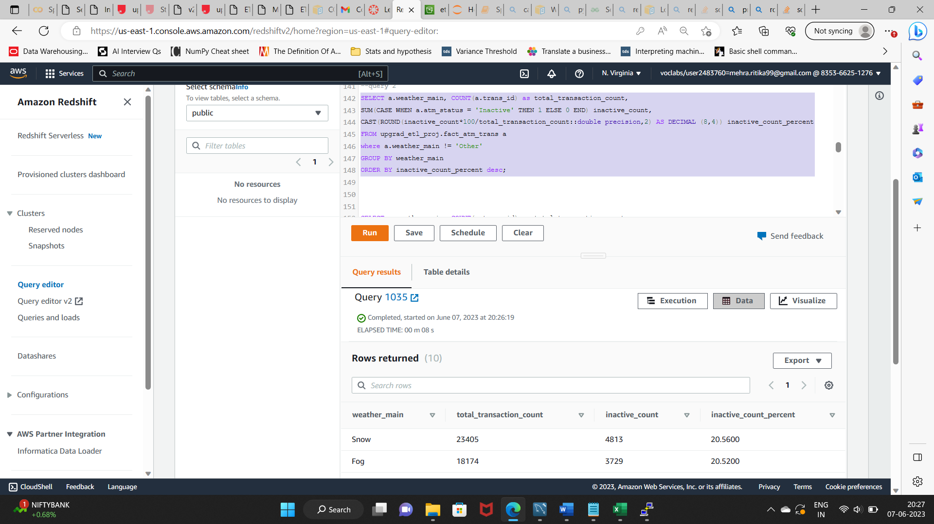

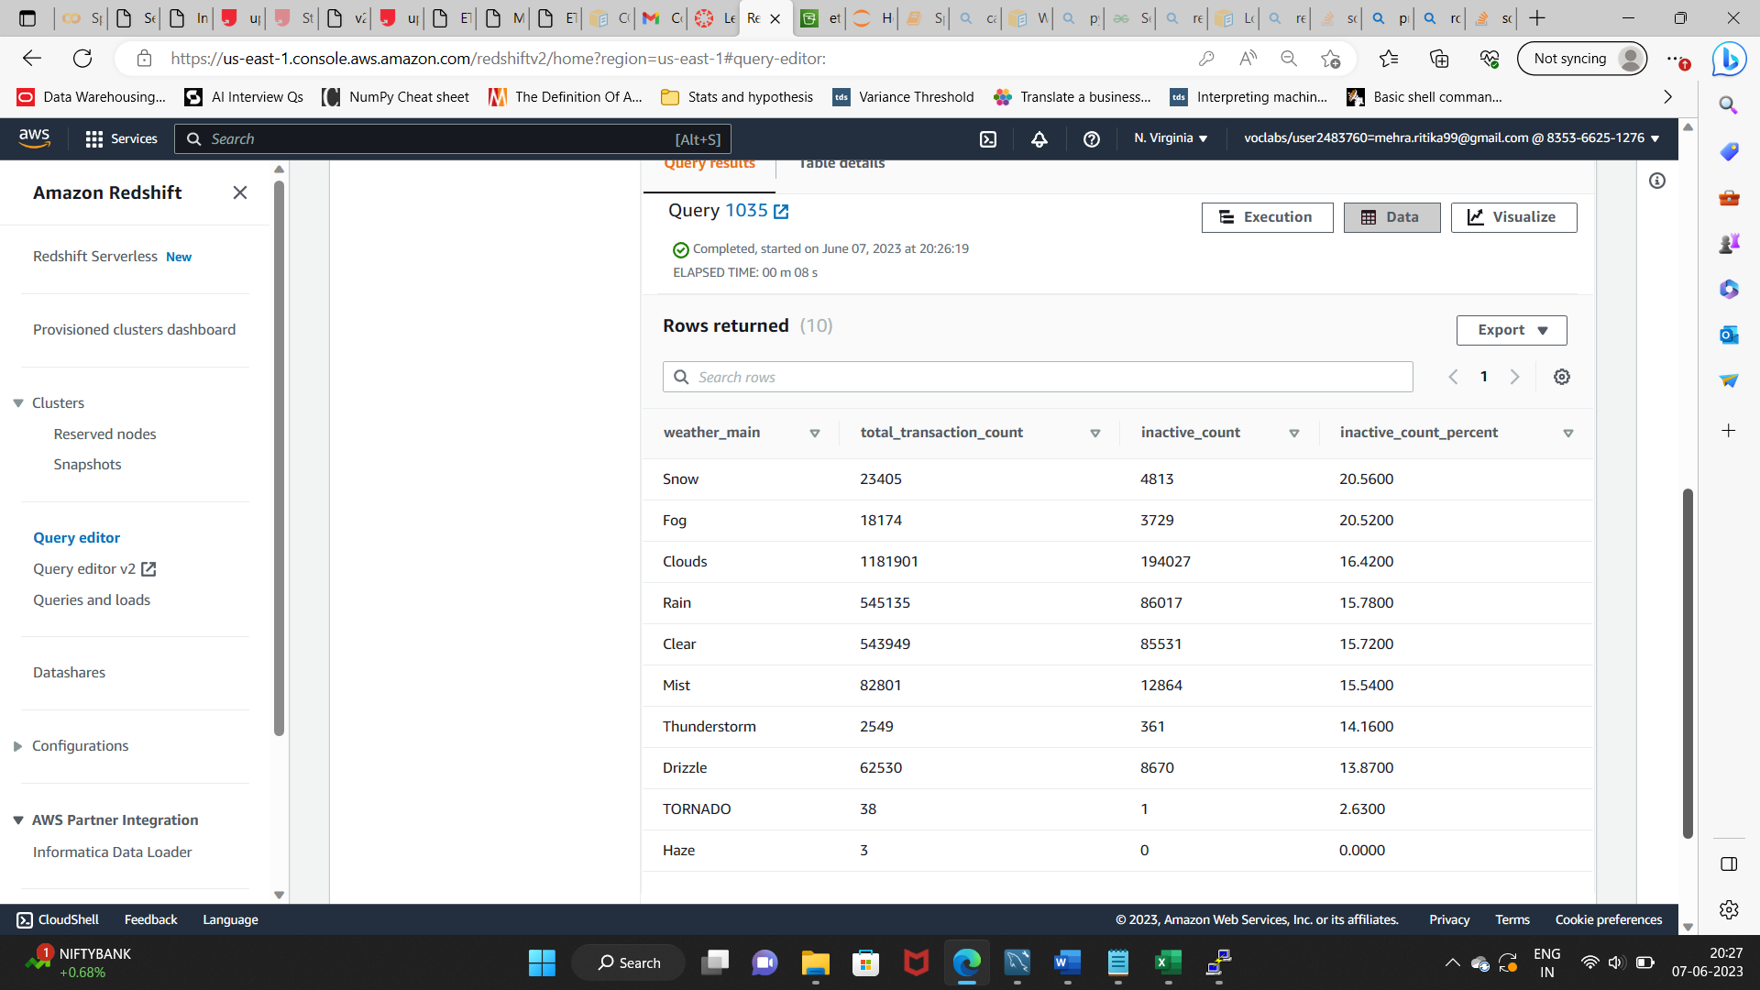

1. **Top 10 ATMs with the most number of transactions throughout the year**

SELECT atm_number, atm_manufacturer, location, total_transaction_count

FROM

(SELECT c.atm_number, c.atm_manufacturer, b.location, COUNT(a.trans_id) total_transaction_count, DENSE_RANK() OVER(ORDER BY count(a.trans_id) desc) rank

FROM upgrad_etl_proj.fact_atm_trans a, upgrad_etl_proj.dim_location b, upgrad_etl_proj.dim_atm c

WHERE a.weather_loc_id = b.location_id

AND a.atm_id = c.atm_id

AND b.location_id = c.atm_location_id

GROUP BY c.atm_number, c.atm_manufacturer, b.location)

WHERE rank <=10;

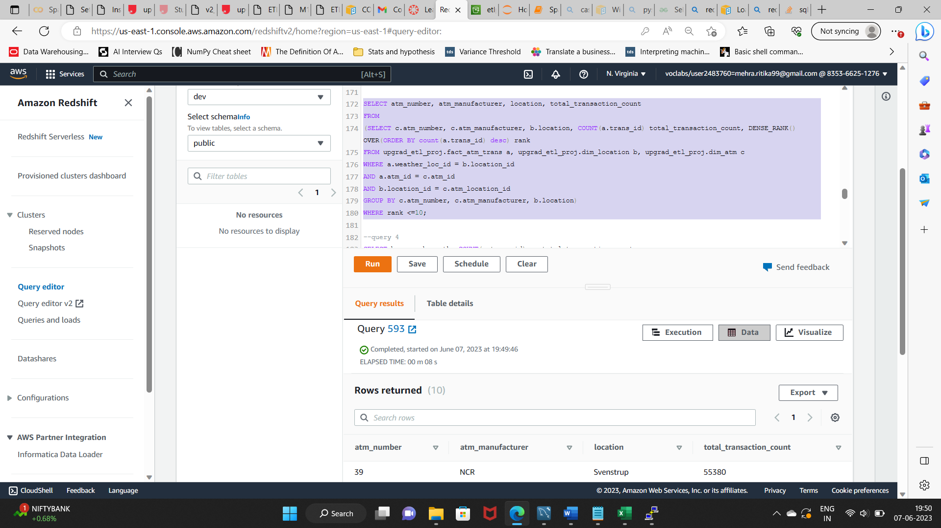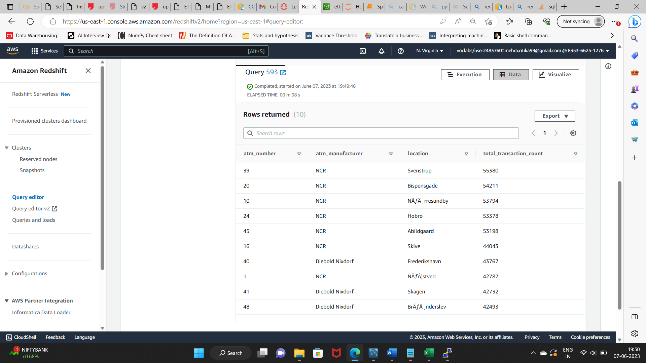

1. **Number of overall ATM transactions going inactive per month for each month**

SELECT b.year, b.month, COUNT(a.trans_id) as total_transaction_count,

SUM(CASE WHEN a.atm_status = 'Inactive' THEN 1 ELSE 0 END) inactive_count,

CAST(ROUND(inactive_count*100/total_transaction_count::double precision,2) AS DECIMAL (8,4)) inactive_count_percent

FROM upgrad_etl_proj.fact_atm_trans a, upgrad_etl_proj.dim_date b

WHERE a.date_id = b.date_id

GROUP BY b.year, b.month

ORDER BY b.month;

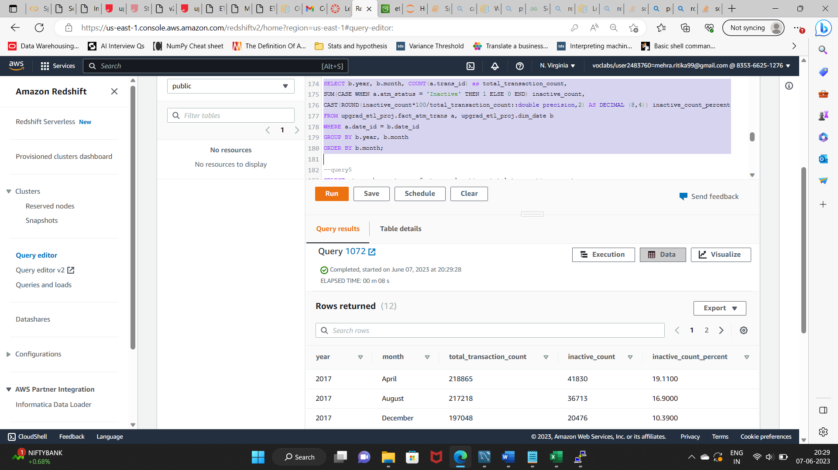

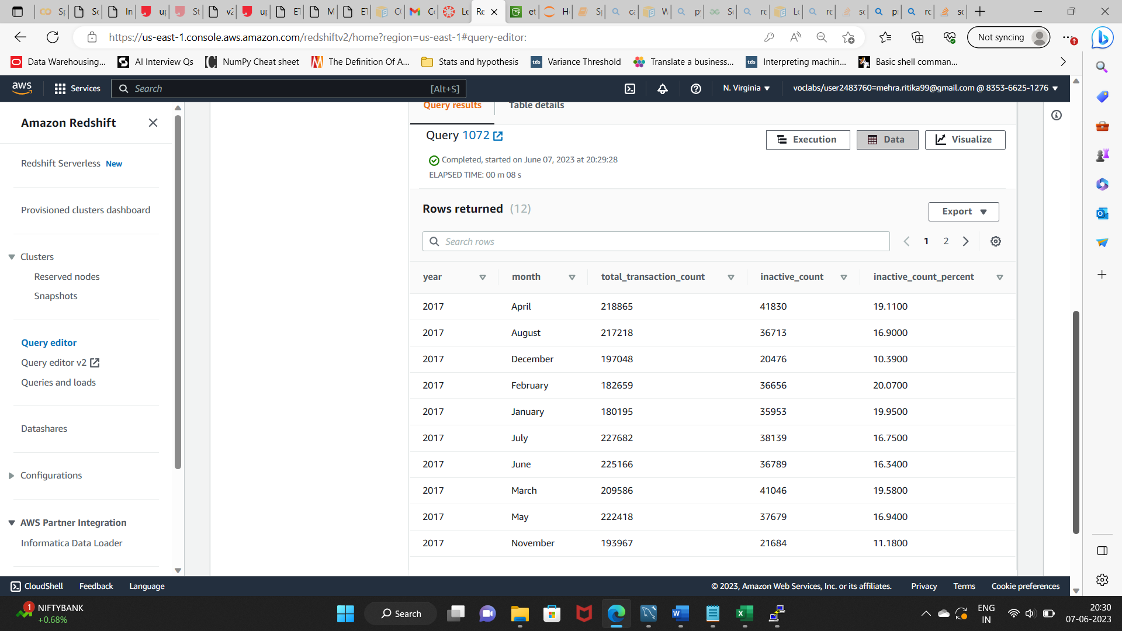

1. **Top 10 ATMs with the highest total withdrawn amount throughout the year**

SELECT atm_number, atm_manufacturer, location, total_transaction_amount

FROM(SELECT c.atm_number, c.atm_manufacturer, b.location, SUM(a.transaction_amount) total_transaction_amount, DENSE_RANK() OVER(ORDER BY SUM(a.transaction_amount) desc) rank

FROM upgrad_etl_proj.fact_atm_trans a, upgrad_etl_proj.dim_location b, upgrad_etl_proj.dim_atm c

WHERE a.weather_loc_id = b.location_id

AND a.atm_id = c.atm_id

AND b.location_id = c.atm_location_id

GROUP BY c.atm_number, c.atm_manufacturer, b.location)

WHERE rank <=10;

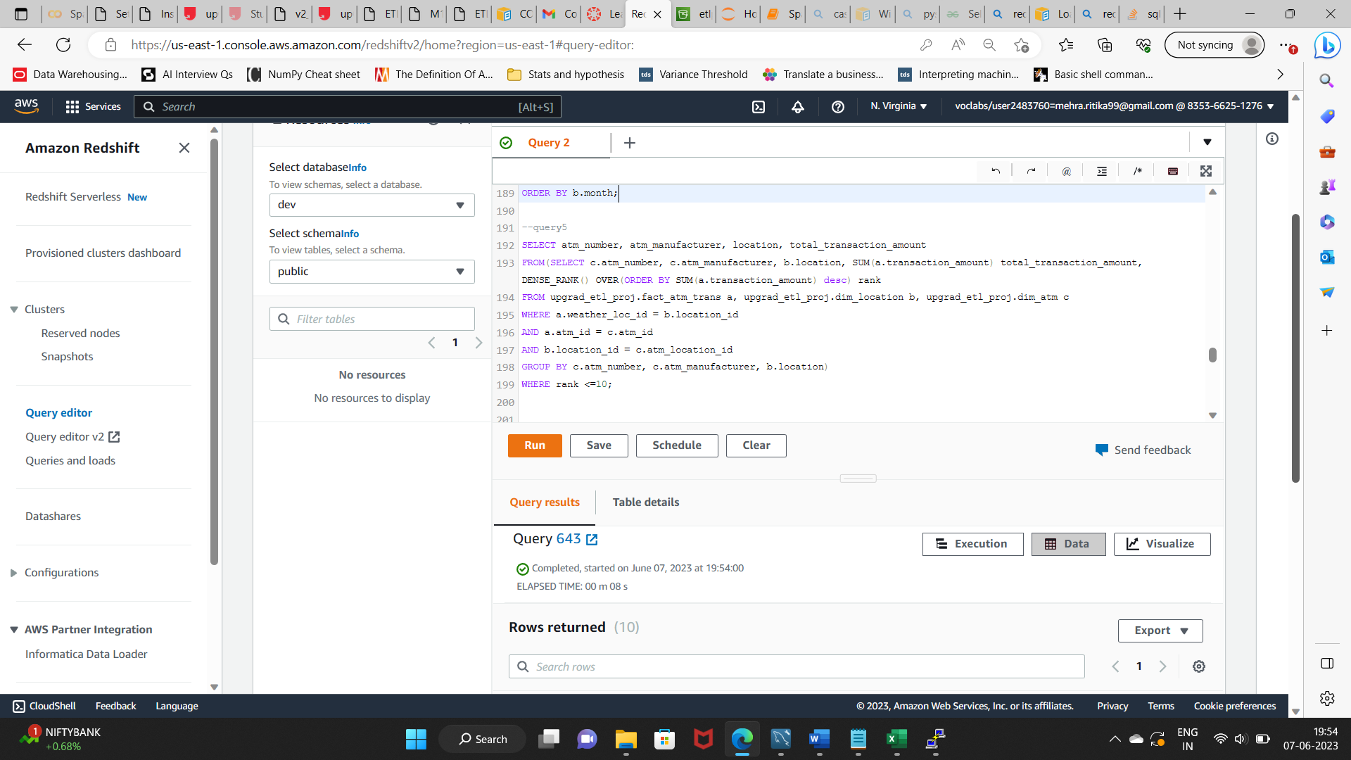

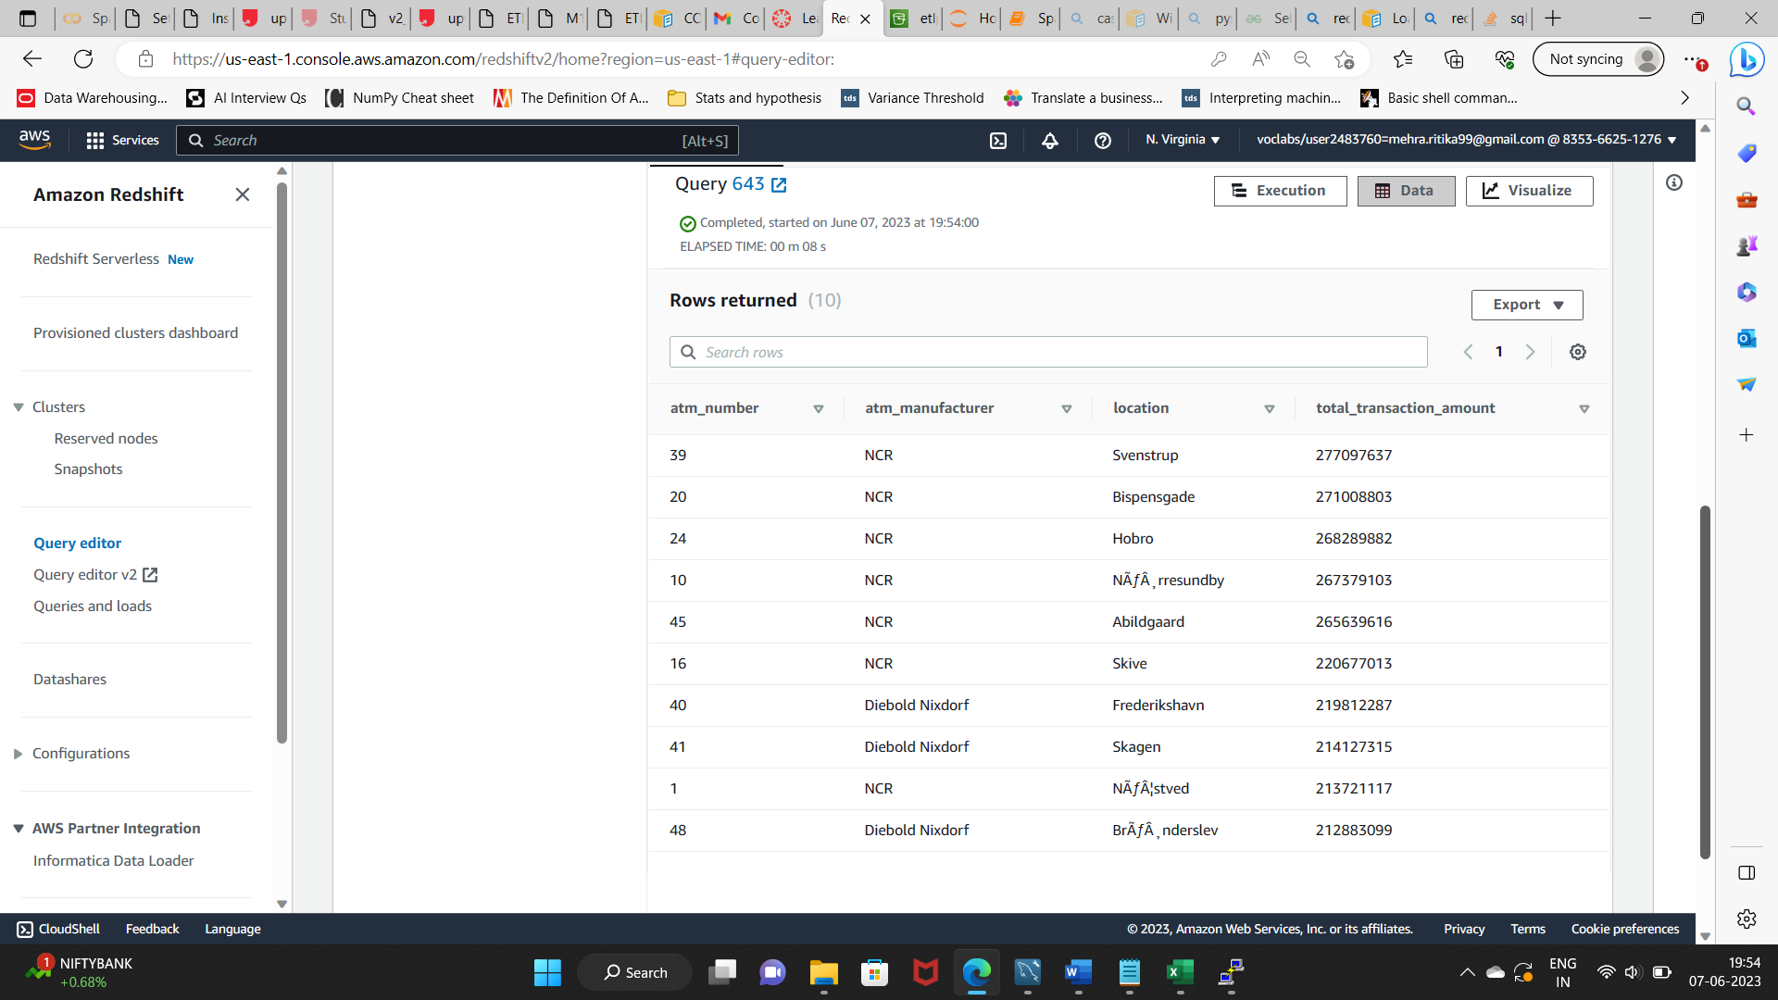

1. **Number of failed ATM transactions across various card types**

SELECT b.card_type, COUNT(a.trans_id) as total_transaction_count,

SUM(CASE WHEN a.atm_status = 'Inactive' THEN 1 ELSE 0 END) inactive_count,

CAST(ROUND(inactive_count*100/total_transaction_count::double precision,2) AS DECIMAL (8,4)) inactive_count_percent

FROM upgrad_etl_proj.fact_atm_trans a, upgrad_etl_proj.dim_card_type b

WHERE a.card_type_id = b.card_type_id

GROUP BY b.card_type

ORDER BY inactive_count_percent desc;

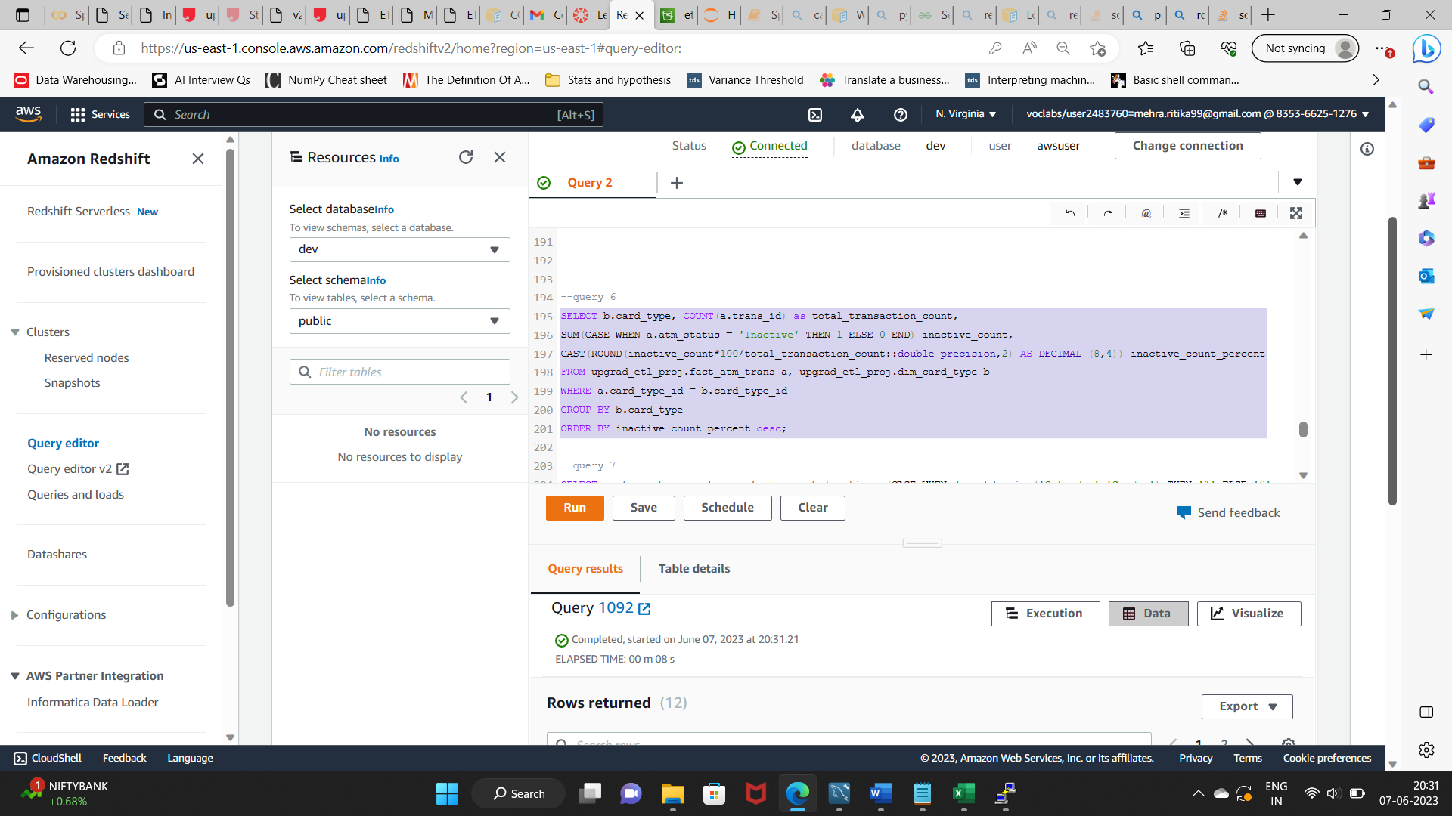

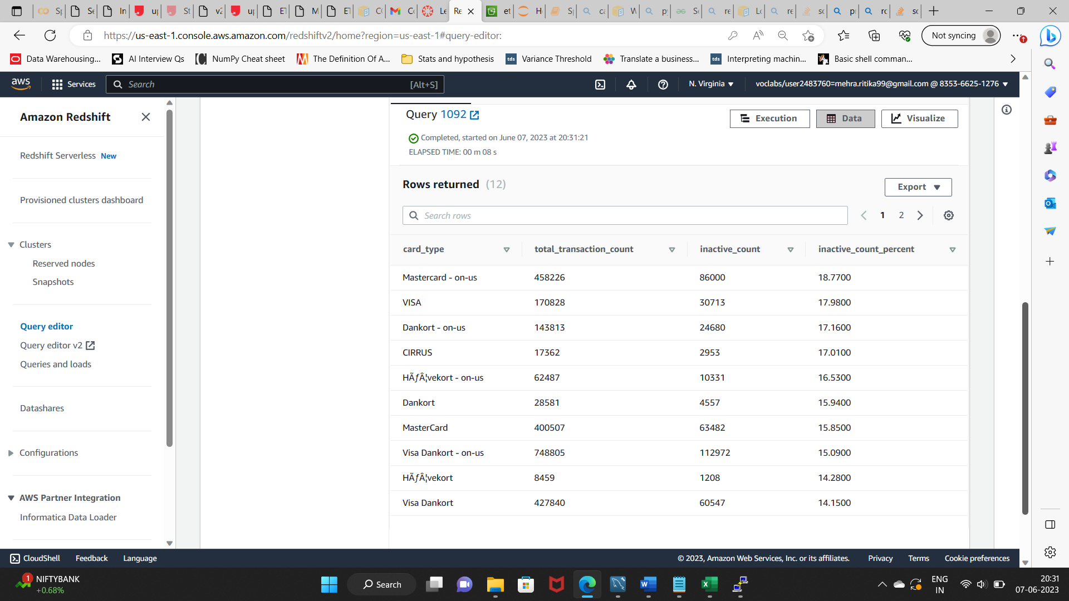

1. **Number of transactions happening on an ATM on weekdays and on weekends throughout the year. Order this by the ATM_number, ATM_manufacturer, location, weekend_flag and then total_transaction_count**

SELECT c.atm_number, c.atm_manufacturer, b.location, (CASE WHEN d.weekday in ('Saturday','Sunday') THEN '1' ELSE '0' END) weekend_flag, count(a.trans_id) total_transaction_count

FROM upgrad_etl_proj.fact_atm_trans a, upgrad_etl_proj.dim_location b, upgrad_etl_proj.dim_atm c, upgrad_etl_proj.dim_date d

WHERE a.weather_loc_id = b.location_id

AND a.atm_id = c.atm_id

AND b.location_id = c.atm_location_id

AND d.date_id = a.date_id

GROUP BY c.atm_number, c.atm_manufacturer, b.location, weekend_flag

ORDER BY c.atm_number, total_transaction_count desc;

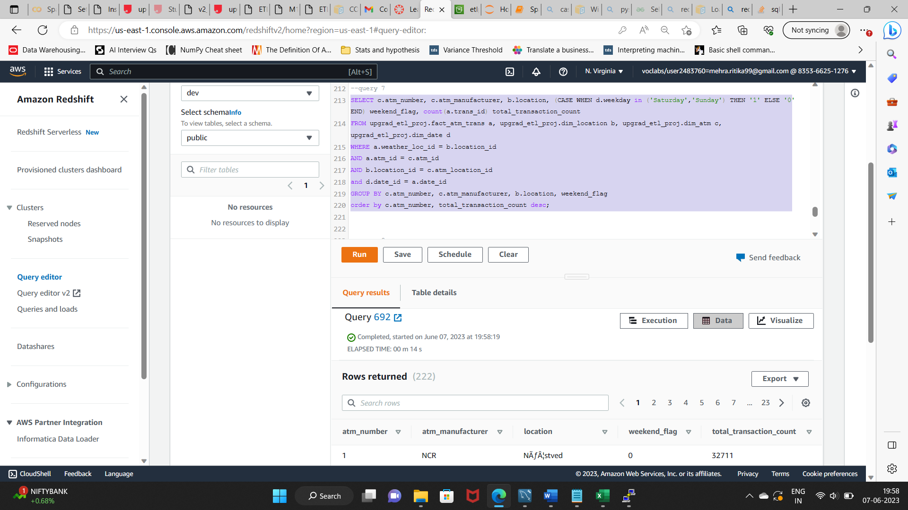

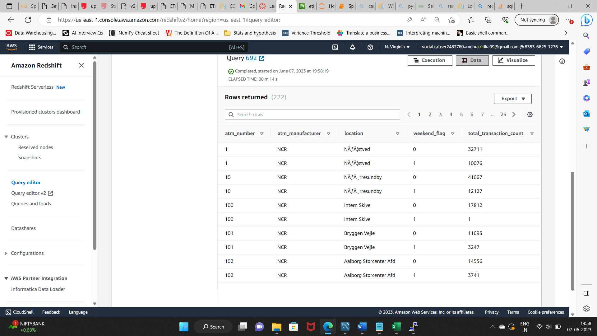

1. **Most active day in each ATMs from location "Vejgaard"**

SELECT atm_number, atm_manufacturer, location, weekday, total_transaction_count from (

SELECT c.atm_number, c.atm_manufacturer, b.location, d.weekday, count(a.*) OVER (PARTITION BY c.atm_manufacturer, d.weekday) as total_transaction_count,

DENSE_RANK() OVER(PARTITION BY c.atm_manufacturer ORDER BY count(a.trans_id) desc) rank

FROM upgrad_etl_proj.fact_atm_trans a, upgrad_etl_proj.dim_location b, upgrad_etl_proj.dim_atm c, upgrad_etl_proj.dim_date d

WHERE a.weather_loc_id = b.location_id

AND b.location = 'Vejgaard'

AND a.atm_id = c.atm_id

AND b.location_id = c.atm_location_id

AND a.date_id = d.date_id

GROUP BY c.atm_number, c.atm_manufacturer, b.location, d.weekday)

WHERE RANK = 1;

